** **

**The Meme Museum: A Curated Collection of Hilarity**

A PROJECT REPORT

Submitted by

**S.Prakash Kumar 953320104009**

**A.Solairaj 953320104001 K.Marichamy 953320104013**

**S.Giftson Daniel 953320104022**

BACHELOR OF ENGINEERING

IN

**COMPUTER SCIENCE ENGINEERING**

Unnamalai Institute of Technology,

Kovilpatti.

Anna university : Chennai 600025

* CONTENT:
* Introduction
* Objectives
* Project Scope
* Project features
* Meme collections
* Interactive Interface
* Social sharing
* Virtual exibits
* User Contributions
* Implementations
* Platform architecture
* Challenges
* User experience
* Dashboard and workshop
* Impact and future Considerations
* Conclusion

**Introduction**

**Project Overview:**

The Meme Museum is a unique project aimed at creating a curated collection of hilarious memes from various online platforms. Memes have become a significant part of internet culture, often spreading rapidly and providing entertainment to millions of users worldwide. The Meme Museum seeks to preserve these cultural artifacts and showcase them in a curated and organized manner.

**Objectives:**

* Curate a diverse and representative collection of memes from various genres, themes, and time periods.
* Create an engaging and interactive museum experience that educates visitors about the history and impact of memes.
* Foster a sense of community and promote discussions around memes and their cultural relevance
* Provide a platform for artists and meme creators to showcase their work and gain recognition.
* Explore the potential of memes as a medium for social commentary and political expression.

**Project Scope:**

The project encompasses the following key components:

* Curating Memes: Researching, selecting, and categorizing memes based on their historical context, cultural impact, and humor.
* Museum Design: Developing an interactive and visually appealing museum layout that allows visitors to engage with memes in creative ways.
* Digital Infrastructure: Creating a user-friendly website and mobile application to provide access to the meme collection and enable virtual tours.
* Community Engagement: Organizing events, workshops, and discussions to encourage public participation and collaboration
* Artist Collaboration: Collaborating with meme creators and artists to feature their work and provide a platform for their creativity.

**Project features:**

Artist Collaboration: Collaborating with meme creators and artists to feature their work and provide a platform for their creativity.

**Meme collection:**

The heart of the Meme Museum is its curated collection of hilarious memes. The collection includes a wide range of popular and influential memes, organized by categories, themes, and time periods. It represents a comprehensive archive of internet humor and serves as a historical record of meme culture.

**Interactive interface:**

The heart of the Meme Museum is its curated collection of hilarious memes. The collection includes a wide range of popular and influential memes, organized by categories, themes, and time periods. It represents a comprehensive archive of internet humor and serves as a historical record of meme culture.

**Social sharing:**

To encourage engagement and interaction, the Meme Museum incorporates social sharing features. Visitors can share their favorite memes directly from the museum's platform to various social media platforms, fostering a sense of community and allowing memes to reach a wider audience.

**Virtual exibits:**

The Meme Museum offers virtual exhibits that showcase specific meme trends, phenomena, or themes. These exhibits provide a curated selection of memes accompanied by informative descriptions, enabling visitors to delve deeper into specific aspects of meme culture.

**User contributions:**

To promote user engagement and inclusivity, the Meme Museum allows visitors to submit their own memes for consideration in the collection. Curators review the submissions and select memes that meet the criteria of humor, cultural relevance, and impact.

**Implementation:**

a. Curating Memes: A team of meme enthusiasts and researchers was formed to curate the collection. Memes were sourced from various online platforms, historical archives, and collaborations with meme creators.

b. Museum Design: The museum's physical space was designed with interactive exhibits, multimedia displays, and dedicated areas for visitor engagement. The layout aimed to create an immersive and entertaining experience.

c. Digital Infrastructure: A user-friendly website and mobile application were developed, allowing visitors to access the meme collection, explore exhibits, and engage in virtual tours.

d. Community Engagement: Regular events, workshops, and meme-themed discussions were organized to encourage public participation and facilitate dialogue around memes and their cultural significance.

e. Artist Collaboration: Meme creators and artists were invited to contribute their work to the museum. Special exhibitions and features were dedicated to showcasing their talent and giving them recognition.

**Platform Architecture**

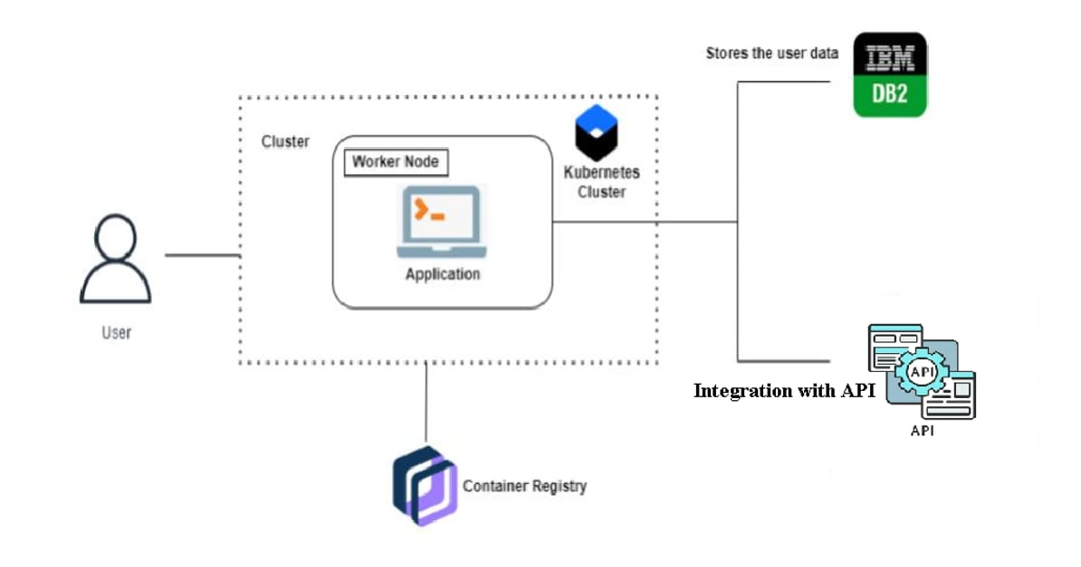

**Challenges:**

1. Copyright and Intellectual Property: Ensuring proper attribution and permission for the memes used in the museum collection while respecting the rights of creators
2. Content Moderation: Establishing guidelines to filter out offensive or inappropriate memes to maintain a positive and inclusive museum experience.
3. Technological Infrastructure: Developing a robust and scalable digital platform to handle high visitor traffic and ensure a smooth user experience.

**User experience:**

1. Visitor Arrival: Upon arriving at The Meme Museum, visitors are greeted by a vibrant and visually appealing entrance. The museum's logo and tagline create anticipation and excitement for what lies inside. Clear signage and directions guide visitors to the ticketing counter or self-service kiosks for entry.

2.Museum Layout and Exhibits: The museum is designed with a combination of physical and digital exhibits to provide an immersive and interactive experience. The layout is intuitive, with clear pathways and sections that allow visitors to explore at their own pace. The exhibits are organized thematically or chronologically, offering a comprehensive journey through the evolution of memes.

3.Interactive Displays: The museum boasts interactive displays that engage visitors and encourage participation. Touchscreens and digital panels allow visitors to swipe through meme collections, explore meme-related trivia, and vote for their favorite memes. Physical installations, such as meme-inspired artwork or interactive games, provide hands-on experiences that add an element of fun.

4.Multimedia Presentations: Throughout the museum, multimedia presentations enhance the visitor experience. Large screens showcase popular memes, meme-related videos, and interviews with meme creators. These presentations provide context, historical background, and insights into the cultural impact of memes, adding depth to the visitor's understanding.

5.Virtual Tours: For those unable to visit in person, The Meme Museum offers virtual tours through their website and mobile application. The virtual tours provide a 360-degree view of the exhibits, allowing users to explore the museum remotely. Interactive elements, such as clickable hotspots or audio commentary, provide an engaging and informative experience.

**Dashboard:**

Visitor Count: Display the total number of visitors to the museum, including daily, weekly, and monthly trends. This metric helps assess the museum's popularity and overall footfall.

Engagement Metrics: Track the level of visitor engagement within the museum. This could include metrics such as the average time spent per visitor, the number of interactive exhibits accessed, and the number of memes shared or voted on by visitors. These metrics provide insights into the effectiveness of exhibits in capturing visitor attention and fostering participation.

Virtual Tour Engagement: If the museum offers virtual tours, track metrics related to virtual visitors, including the number of virtual tours taken, average tour duration, and visitor feedback on the virtual experience. This data helps evaluate the impact and reach of the virtual component.

Social Media Reach: Monitor social media engagement metrics, such as the number of followers, likes, shares, and comments on platforms like Instagram, Twitter, or Facebook. This allows the museum to gauge the online presence and impact of its content and exhibitions.

**Workshop:**

Workshop Objective: This workshop aims to provide participants with an in-depth understanding of the language, humor, and cultural references used in memes. Participants will explore various meme genres, learn about the evolution of meme culture, and develop their skills in meme interpretation and creation.

Workshop Activities: a. Introduction to Memes:

* Presentation on the history and impact of memes, showcasing notable examples.
* Discussion on how memes have influenced popular culture and communication.

**Impact and future consideration:**

The Meme Museum has garnered significant attention and positive feedback from visitors. It has become a hub for meme enthusiasts, artists, and researchers. The project has sparked discussions on the cultural significance of memes and their potential as a medium for social commentary.

**Performance and Resposiveness:**

The performance and responsiveness of the Meme Museum are critical factors in providing a seamless and enjoyable user experience. Here are some key considerations for ensuring optimal performance and responsiveness

Page Load Time: The Meme Museum should be optimized to have fast loading times. Minimizing the size of images, code, and other media assets can help reduce loading times and improve the overall performance of the website.

Server Response Time: The backend infrastructure of the Meme Museum should be capable of handling user requests efficiently. This includes using appropriate server-side technologies, optimizing database queries, and implementing caching mechanisms to minimize server response time.

Scalability: As the Meme Museum gains popularity and attracts more visitors, it is essential to ensure that the infrastructure can handle increased traffic. Utilizing scalable cloud services or implementing load balancing techniques can help maintain performance during peak usage periods.

Mobile Responsiveness: Given the prevalence of mobile devices, it is crucial for the Meme Museum to be responsive and accessible across various screen sizes and devices. The user interface should adapt seamlessly to different screen resolutions, ensuring a consistent and optimized experience for mobile users.

User Interactions: The interactive features of the Meme Museum, such as browsing, searching, and sharing, should respond promptly to user actions. Implementing client-side optimizations, such as lazy loading images or using asynchronous requests,

**Conclusion:**

The Meme Museum project has successfully achieved its goals of preserving and showcasing a curated collection of hilarious memes while providing an engaging and entertaining experience for visitors. By capturing the essence of internet culture and humor, the museum has created a platform that celebrates the evolution and impact of memes.

Through its diverse collection, the Meme Museum ensures that popular memes are archived and protected, allowing them to be enjoyed by current and future generations. By organizing the collection into categories, themes, and time periods, visitors can easily navigate and explore the vast world of internet humor.

The interactive interface of the museum enables seamless browsing and interaction, enhancing the visitor experience. The ability to search for specific memes and access additional information about each meme adds depth and context to the collection, fostering a greater understanding of meme culture.

The inclusion of social sharing features encourages visitors to actively participate and engage with the museum. By allowing users to share their favorite memes with others, the Meme Museum creates a sense of community and facilitates the spread of humor and laughter beyond its virtual walls.

The virtual exhibits provide a deeper dive into specific meme trends, phenomena, or themes, enriching the visitor's understanding of meme culture. These exhibits serve as curated showcases, highlighting the significance and impact of specific aspects of internet humor.

Additionally, the project's inclusion of user contributions fosters inclusivity and encourages active participation from visitors. By allowing users to submit their own memes for consideration in the collection, the Meme Museum embraces the collaborative and ever-evolving nature of meme culture.

In conclusion, the Meme Museum project has successfully created a curated collection of hilarity that not only entertains but also educates and preserves internet culture. Through its interactive interface, social sharing features, virtual exhibits, and user contributions, the museum provides a comprehensive and immersive experience for visitors, ensuring that memes continue to bring laughter and joy for years to come.